**Mass Transfer Operations - I**

**Prof. Bishnupada Mandal**

**Department of Chemical Engineering**

**Indian Institute of Technology Guwahati**

**Diffusion Mass Transfer - II**

**Lecture – 07**

**Gas Phase Diffusion Coefficient prediction and liquid phase diffusion coefficient measurement and prediction**

Welcome to the 7’th lecture on Mass Transfer Operation. In this module, we are discussing on Diffusion Mass Transfer.

(Refer Slide Time: 00:42)

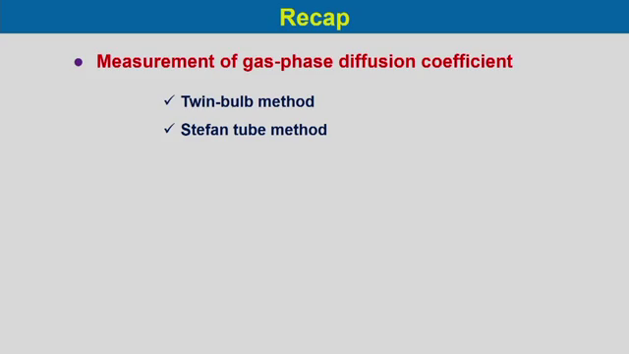

So, before going to the lecture let us have small recap on our previous lecture. In our previous lecture, we have discussed measurement of gas phase diffusion coefficient and under this experimental measurement of the diffusion coefficient we have considered 2 methods. The first method is Twin-bulb method and we have considered counter current diffusion for 2 components using the twin bulb method and we have solved certain problems on this method.

The second method we have considered is Stefan tube method, where we considered the diffusion of a component through non diffusing B. In this lecture we will consider 3 cases one is gas phase diffusion coefficient predictions, then we will consider liquid phase diffusion coefficient measurements and then third case we will consider the liquid phase diffusion coefficient prediction.

(Refer Slide Time: 02:02)

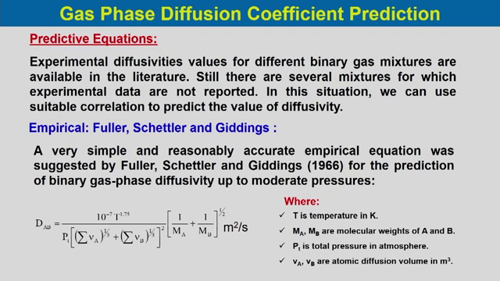

The first one is gas phase diffusion coefficient prediction. Predictive equations basically in many situations we have experimental diffusivities values for binary gas mixtures and that are available in the literature, but still there are several mixtures for which experimental data are not reported. So, in this situation we can use suitable correlation to predict the value of diffusivity. These which values the predictive equations which are obtained from the predictive equation is based on some relations which is developed for different system based on the variation of the temperature pressure of the systems or the molecular weight of the components or their molecular volumes, so based on that these equations the predictive equations are proposed.

One of the empirical relations is Fuller equations. So, a very simple and reasonably accurate empirical equations which was proposed by Fuller et al in 1966 for the prediction of binary gas phase diffusivity which is up to moderate pressure which 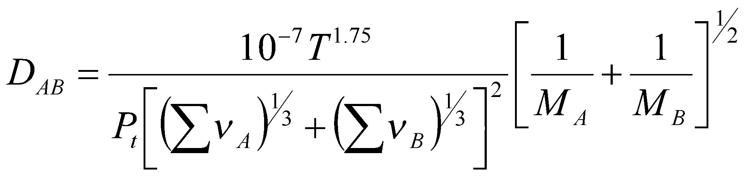 DAB is the diffusion coefficient of component A into component B mutual diffusivities, where T is the temperature in Kelvin MA and MB are the molecular weights of component A and B, Pt is the total pressure in atmosphere and VA VB are the atomic diffusion volumes that is in metre cube.

(Refer Slide Time: 04:40)

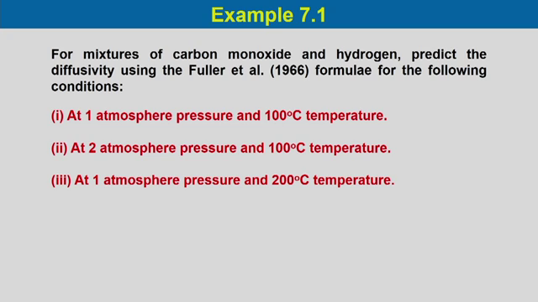

Now, let us take an example to calculate that diffusion coefficient for mixtures of carbon monoxide and hydrogen, we need to predict the divisibility using Fuller et al 1966 formula for the following conditions. At 1 atmosphere pressure and 100 degree centigrade temperature the second case is at 2 atmosphere pressure and 100 degree centigrade temperature that means the temperature kept constant and pressure is doubled.

(Refer Slide Time: 05:33)

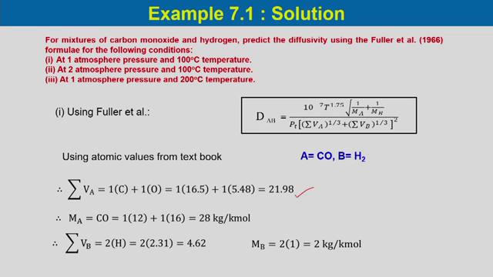

In the third case is at 1 atmosphere pressure and at 200 degree centigrade temperature, in this case compare to the first problem the pressure remains constant and temperature is doubled.